Hixon Elementary Learning Commons
Access to E-Resources
Go to www.dlc.sd57.bc.ca and click on

For: EBSCO Resources (including Consumer Health Complete); KnowBC Encyclopedia of British Columbia, and:
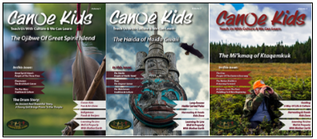
Please email me at cneedoba@sd57.bc.ca for the login information.

For: Gale Power Search
Please email me at cneedoba@sd57.bc.ca for the login information.

For: Learn360 generic district account
Please email me at cneedoba@sd57.bc.ca for the login information.
*make individual account to save playlists and download videos
Generic student account:
Please email me at cneedoba@sd57.bc.ca for the login information.

For: TigTag Science to create individual account
https://www.go.twigeducation.com/bcdc
Please email me at cneedoba@sd57.bc.ca for the login information.

E-Resources that do NOT need passwords:
GALE Resources: Global Issues in Context, Canada in Context, Science in Context, Gale Virtual Reference Library
National Film Board (create an individual account with DLC link for CAMPUS access)
Historica Canada
CommonSenseMedia
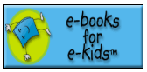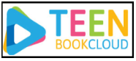

For a Schedule of Free Online Events and Activities for Kids at Home please go to:
https://www.commonsensemedia.org/blog/free-online-events-activities-kids-at-home-coronavirus
(Includes things like Virtual Story-times, Drawing Lessons, Music classes and performances, and more)

Additional Free Resources:
Storyline Online  https://www.storylineonline.net  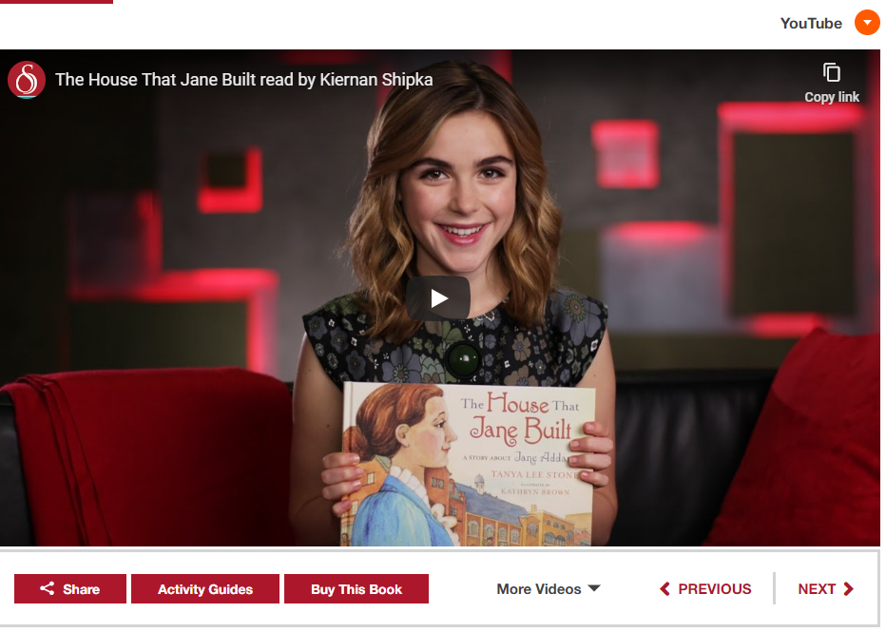 | Mathology Little Books  https://www.pearsoncanadaschool.com/  index.cfm?locator=PS3e1i  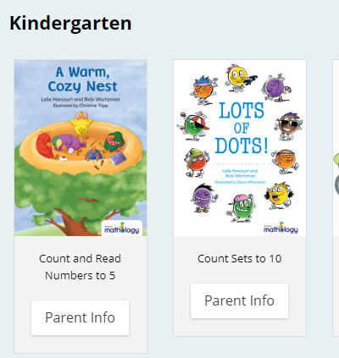
Duolingo  https://www.duolingo.com/  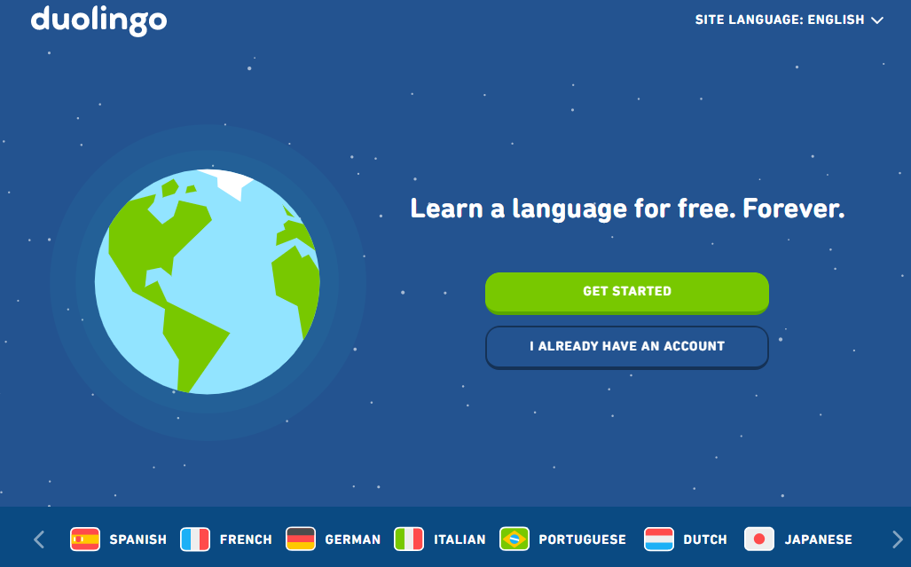 | NASA Kids’ Club  https://www.nasa.gov/kidsclub/index.html  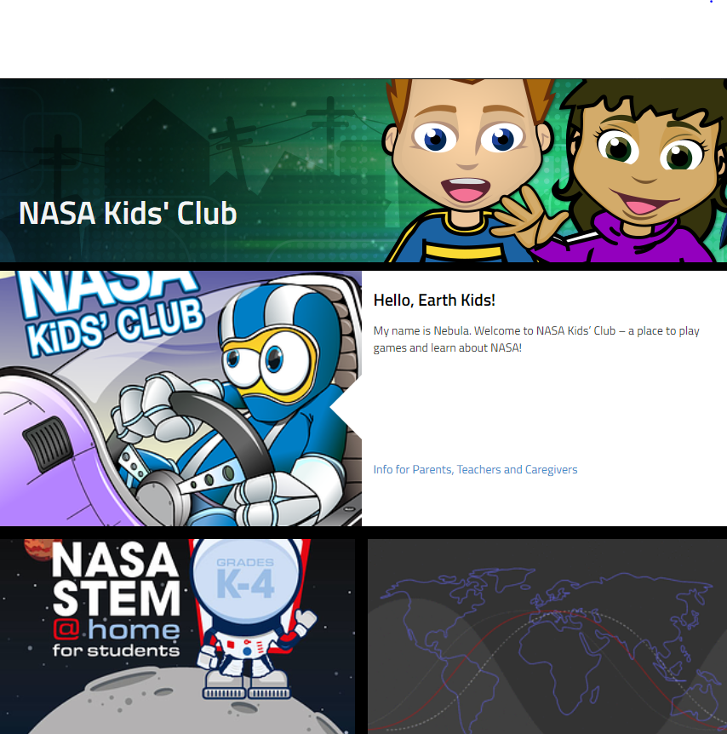
Smithsonian for Kids  https://www.si.edu/kids  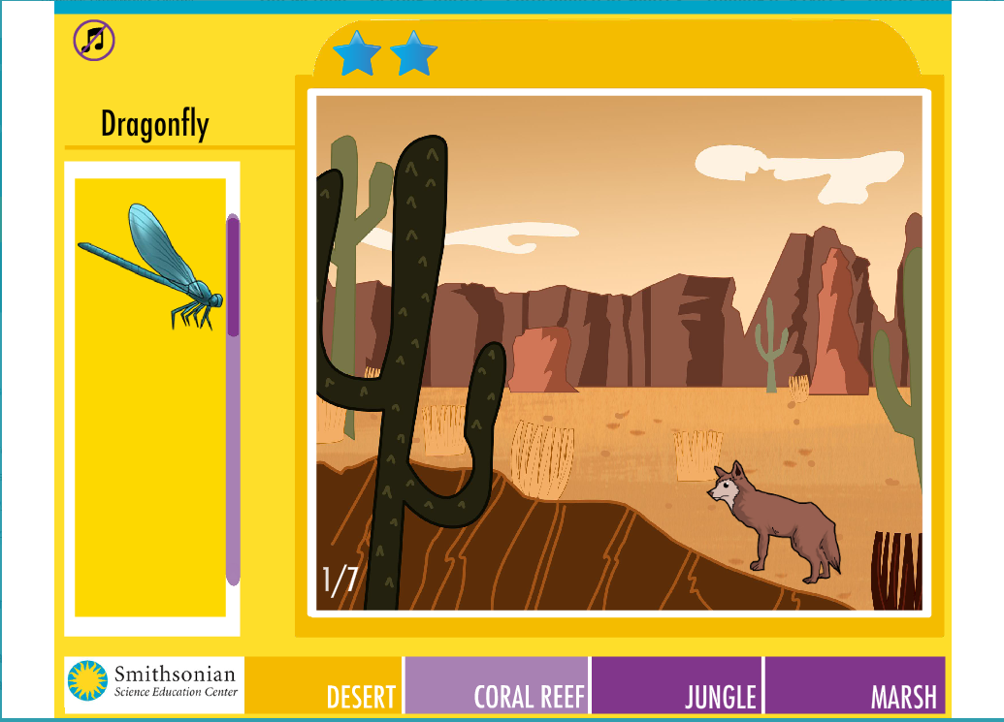 | Scratch  https://scratch.mit.edu/  