Access to District E-Resources
Go to www.dlc.sd57.bc.ca and click on

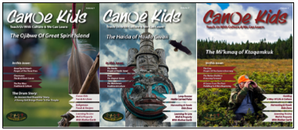
Canoe Kids Magazine
Please email me at cneedoba@sd57.bc.ca for the login information.

Can-Core Video Streaming
Can-Core is a powerful video streaming platform correlated to the BC K-12 curriculum and powered by McIntyre Media. Videos in English, French, Coast Salish, Cree, and other languages available.
Free trial login:
Please email me at cneedoba@sd57.bc.ca for the login information.

Others:
SD 71 has a great site:
http://www3.sd71.bc.ca/School/abed/resources/teacher/Pages/Grades-4-7-Resources.aspx#/=
https://www.aptn.ca/
https://www.firstvoices.com/
http://www.fnesc.ca/learningfirstpeoples/
https://moa.ubc.ca/2020/03/moafromhome-stay-connected-online/

